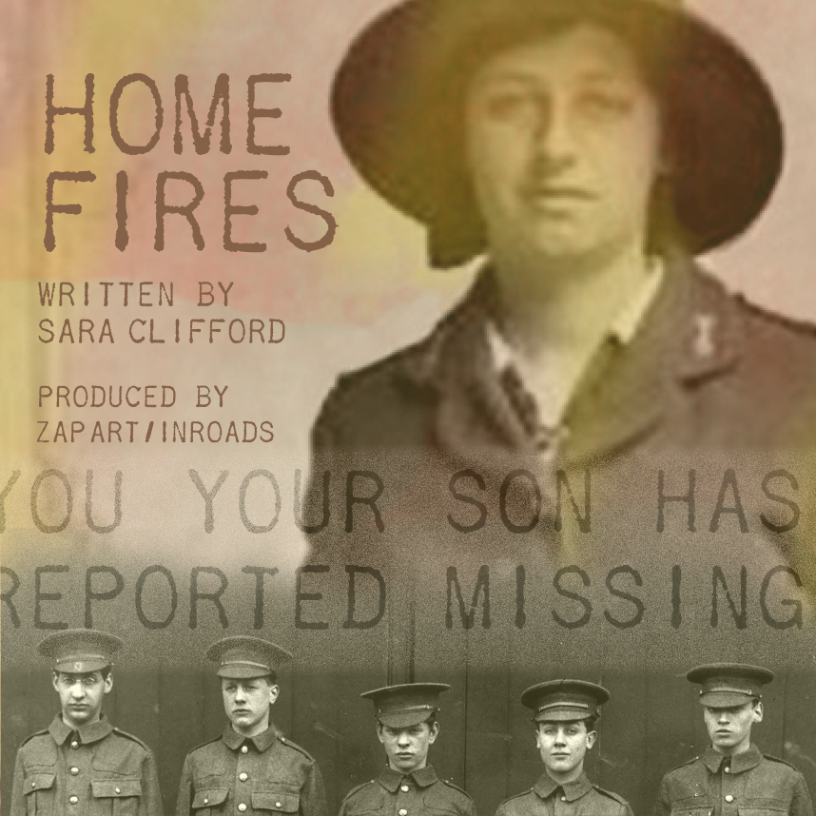
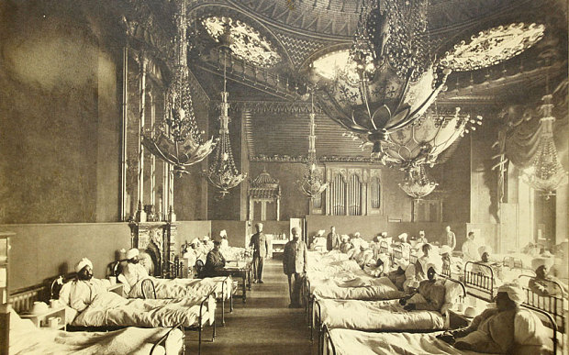 | 'HOME FIRES'  Open Day at Newhaven Fort  Saturday 7th March 2015  10am-5pm

2014 marks the Centenary of the First World War, a landmark anniversary for Britain and the world.
'Home Fires' is a new arts / heritage project and brand new play by Sara Clifford exploring the role Newhaven, Seaford and their surrounding villages played during the First World War. The play will be performed at Newhaven Fort 18-21st March 2015
In the lead up to our performance of 'Home Fires, the creative team are running a series of talks, workshops , stalls and exhibition events. Come and join us for a full day of activities to remember and learn about Newhaven and Seaford's WW1 heritage. Stalls include: Gateways To The First World War, Royal British Legion, Blind Veterans UK and others.
10 - 5
'HAVE A GO' ARTS & CRAFTS WORKSHOPS WITH CAROL HAVARD, FROM ART TECHNIQUES,AND AMANDA DAVIDSON
11 – 11.05
SHORT INTRODUCTION TO THE PROJECT AND WELCOME BY SARA CLIFFORD (HOME FIRES WRITER)/VERONICA STEPHENS(CREATIVE PRODUCER ZAP ART) AND WAVE LEISURE
11.05 – 11.35
IAN EVEREST, SUSSEX LOCAL HISTORY SPEAKER
Sussex during the Great War : Aspects of daily life in a frontline county within the sounds of the guns on the Western Front.
A time when Sussex was far removed from being a typical English wartime county.
11.30 – 11.55
STUDIO TEMPO, NEWHAVEN DANCE GROUP
DANCE DISPLAY AND ‘HAVE A GO’ CLASS- Romney Hut OR outside café. Dances from the early part of the Twentieth Century
12 –12.30
KEITH BRAIN, LOCAL HISTORIAN
Newhaven Fort and Garrison in the Great War 1914-1918: A talk about the units and men that served in Newhaven Fort and Newhaven Garrison and their activities together with the reasons for the Garrison and the plans for the defence of the Newhaven area.
1.- 1.30
JENNY FLOOD, LOCAL HISTORIAN AND PROJECT OFFICER FOR ‘NEWHAVEN’S FIRST WORLD WAR’
An insight into what life was like for the men and women who lived and worked in Newhaven one hundred100 years ago, using photographs from Newhaven Museum's collection.
2- 2.30
UMI SINHA
Indian soldiers in World War One: Umi will read from her novel, Belonging, to be published in September 2015, describing the experiences of Indian soldiers in the trenches and Mesopotamia, and the Indian Hospital in Brighton, followed by a Q and A session about the part that Indian soldiers played in the war.
3 – 3.30
HEIDI WATKINS, COUNTY OF SUSSEX TRUMPETER TO THE ROYAL BRITISH LEGION
The role of the Bugler with the Regiment
Local community organisations are invited to book a stall at the event to promote their activities.
For further information, please contact:
Email: newhavenww1@gmail.com Tel: 01273 500842
Keep up to date through our Facebook page: https://www.facebook.com/pages/Home-Fires-A-haunting-story-of-love-and-loss-during-the-Great-War/146208122219503

For Newhaven Fort admission prices visit: www.newhavenfort.org.uk www.inroads.org.uk www.zapuk.co.uk

