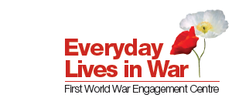

2019 WW1 Engagement Centres Festival – ‘Legacies of the First World War’

What is your idea for participating in the festival?

Please describe what you would like to do at the festival (in no more than 200 words):

How will you use this event to reflect on your experience of collaborative working with an academic or community organisation?

Who is the intended audience for your idea? Please indicate how you would be able to help promote the event.

Which theme is the proposal linked to?
22 & 23 March 2019: Birmingham, Midland Arts Centre, theme ‘Diversity’
18-25 May 2019: Northern Ireland (multiple venues), theme ‘Shared heritage’
July 2019 (dates tbc): South Wales (multiple venues), theme ‘Community activism’
30 & 31 August 2019: Glasgow, Glasgow Women’s Library, theme ‘Women and war’

Please tell us about any technical requirements that you might have:

We have a limited budget for bursaries to cover the costs of community organisations being able to attend and present their work. Please indicate how much you are likely to require to enable you to attend the festival.

Please provide your contact details:

Please send to Nicola Gauld, Voices Coordinator, n.gauld@bham.ac.uk, by 1 October 2018 with the subject heading: WW1 Festival and the location your proposal is for.

